**A SCALABLE TO-DO APPLICATION**

**A NAAN MUDHALVAN REPORT**

***SUBMITTED BY***

**DHANASOORYA M (912421106020)**

**GANESH J (912421106021)**

**BACHELOR OF ENGINEERING**

**IN**

**ELECTRONICS AND COMMUNICATION ENGINEERING**



**SHANMUGANATHAN ENGINEERING COLLEGE**

**ARASAMPATTI, PUDUKKOTTAI – 622 507**

**YEAR & SEMESTER : IV & VII**

**SUBJECT CODE : NM1050**

**COURSE : SAAS APPLIACTION**



**ANNA UNIVERSITY: CHENNAI 600 025**

**NOV/DEC 2024**

**BONAFIDE CERTIFICATE**

Certified that this NM report on the project **“CREATING A SCALABLE TO-DO APPLIACTION”** is the Bonafide work of **“DHANASOORYA M (912421106005) & GANESH J (912421106006)”** who carried out the project work under my guidance.

**SIGNATURE SIGNATURE**

**Dr. D. LATHA, ME., Dr. A. MUTHU MANICKAM M.E., Ph.D**

**NM COURSE COORDINATOR HEAD OF THE DEPARTMENT**

**ASSISTANT PROFESSOR, ASSISTANT PROFESSOR,**

Department of Electronics & Department of Electronics & Communication Engineering, Communication Engineering,

Shanmuganathan Engineering College, Shanmuganathan Engineering College,

Arasampatti – 622 507 Arasampatti – 622 507

Submitted for the Naan Mudhalvan Report on ______________________

INTERNAL EXAMINER EXTERNAL EXAMINER

**ACKNOWLEDGMENT**

**"HARD WORK NEVER FAILS"** So I thank god for having gracefully blessed me to come up till now and thereby giving strength and courage to complete the NM Course successfully. I sincerely submit this NM Project (SaaS) report to the almighty lotus feet.

We wish to acknowledge with thanks to the significant contribution given by the management of our college chairman **"KALLVI VALLAL Mrs.Pichappa Valliammai"**, Correspondent **Dr.P.Manikandan**, and Secretary **Mr.Vishvanathan**, Shanmuganathan Engineering College, Arasampatti, for their extensive support.

I convey my indebted humble thanks to our energetic Principal **Dr. KL. Muthuramu M.E., (W.R), M.E.,(S.E), M.I.S.T.E., F.I.E., Ph.D.,** for his moral support to complete this project.

I am grateful to our Head of the Department **Dr. A. MUTHU MANICKAM M.E., Ph.D.,** and our project co-ordinator **Dr. D. LATHA, M.E.,** for thier valuable guidelines, constructive instruction, constant encouragement, unending helps that have been provided to us during the courses of the project.

I also express my heartfelt thanks to all other staff members of Electronics communication engineering Department for their support. Above all, we thank our parents, for affording us the valuable education till now.

**ABSTRACT**

A scalable to-do application, built using HTML as its foundational structure, is designed to provide users with an intuitive and reliable platform for managing their tasks. HTML offers a semantic and accessible layout for the interface, forming the backbone of the front-end while ensuring compatibility with modern web standards. The application features dynamic task management capabilities, including the ability to create, edit, delete, and categorize tasks. It also supports tagging, deadlines, reminders, and priority-based organization to enhance user productivity. -To ensure a rich and responsive user experience, CSS is used for styling and creating visually appealing designs, while JavaScript enables dynamic interactions such as drag-and-drop functionality, real-time updates, and smooth transitions. The application incorporates responsive design principles, making it accessible across desktop, tablet, and mobile devices, ensuring seamless usability regardless of platform. Scalability is achieved by integrating HTML with robust backend technologies through RESTful or GraphQL APIs, enabling the application to handle an increasing number of users and tasks. Cloud-based databases such as Firebase, MongoDB, or PostgreSQL store user data securely while ensuring high availability. Additional scalability features include server-side rendering for improved load times and caching mechanisms to optimize performance under heavy traffic. Advanced functionalities, such as offline access using service workers and synchronization with real-time databases, make the application reliable even in low-connectivity scenarios. Collaborative features, like task sharing and role-based permissions, allow teams to use the application effectively. Integration with third-party tools, such as calendar apps or productivity suites, enhances the overall utility. By leveraging HTML's universality alongside cutting-edge web development practices, the scalable to-do application ensures long-term performance, flexibility, and reliability, catering to individual users, small teams, and large enterprises alike.

iii

|  |  |  |
| --- | --- | --- |
| **CHAPTER NO.**  **1**  **2**  **3**  **4**  **5**  **6**  **7** | **TITLE**  ABSTRACT  LIST OF FIGURES  **INDRODUCTION**  **SYSTEM ARCHITECTURE**  **FRONTEND LAYER**  3.1) HTML & CSS  3.2) JAVASCRIPT  **SYSTEM FLOW**  **INTERFACE OF THE TO-DO APP**  **CONCLUCION**  **CERTIFICATION** | **PAGE NO.**  III  V  **1**  **2**  3  3  **4**  7  9  10  11 |

**TABLE OF CONTENT**

iv

**LIST OF FIGURES**

|  |  |  |
| --- | --- | --- |
| **FIGURE No.**  2.1.1  3.1.1  3.1.2  3.2.1  3.2.2  4.1.1  5.1.1 | **NAME OF THE FIGURE**  SYSTEM ARCHITECTURE  HTML & CSS  HTML CODE EXECUTION  JAVASCRIPT  JAVASCRIPT CODE EXECUTION  SYSTEM FLOW  INTERFACE OF THE TO-DO APPLICATION    v | **PAGE No.**  2  3  4  5  6  7  9 |

**CHAPTER-1**

**INTRODUCTION**

Task management is a critical aspect of personal productivity and team collaboration in modern life. With the increasing reliance on digital solutions for organizing daily tasks, the demand for flexible and scalable to-do applications has grown significantly. This project aims to develop a scalable to-do application using HTML as the structural foundation, complemented by CSS, JavaScript, and a robust backend infrastructure.

The primary goal of this application is to provide users with a simple, intuitive platform for managing tasks, while also offering advanced features to support scalability, real-time collaboration, and cross-platform accessibility. Key functionalities include task creation, editing, categorization, deadline tracking, and prioritization. To enhance user experience, the application incorporates responsive design, ensuring a seamless interface across desktop, tablet, and mobile devices.

Scalability is a core focus of this project. As the user base and task data grow, the application is designed to maintain high performance and reliability. This is achieved through the integration of cloud-based databases, API-driven communication between the frontend and backend, and the use of caching and load-balancing techniques. Advanced technologies such as service workers ensure offline access, while real-time synchronization keeps task data consistent across devices. Furthermore, the project explores collaborative features such as task sharing, role-based access control, and integration with third-party productivity tools.

1

**CHAPTER-2**

**SYSTEM ARCHITECTURE**

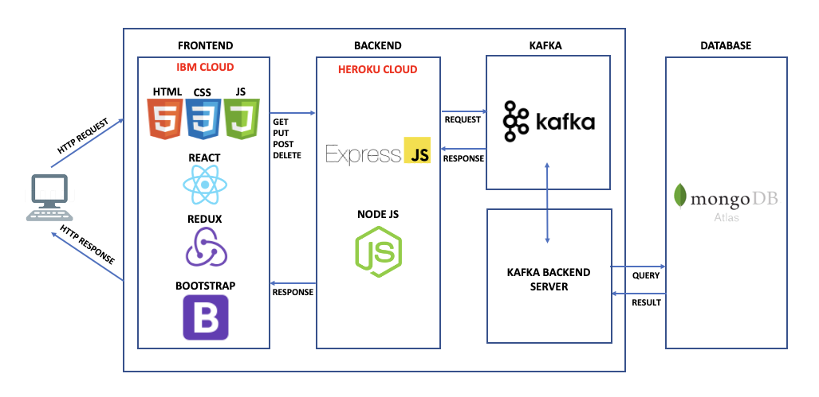 The system architecture of the “Build a RESTful API for an Inventory Management System” project is carefully crafted to be modular, scalable, and efficient, ensuring streamlined communication between various components while delivering robust performance for managing inventory data. This architectural design aims to meet the demands of modern applications, where high levels of data integrity, usability, and adaptability are essential. By organizing the system into clearly defined layers, each with its own specific function, the architecture enables seamless integration and interaction among different modules.

Fig 2.1.1 **System Architecture**

This modularity allows developers to isolate and maintain each component independently, reducing complexity and improving the ease of development and testing. For example, the frontend layer, which comprises HTML, CSS, and JavaScript, is dedicated solely to user interaction, ensuring a responsive and dynamic interface for viewing, adding, updating, and deleting inventory items.

2

**CHAPTER-3**

**FRONTEND LAYER**

The frontend is the client-facing component of the architecture, responsible for interacting with users and displaying inventory data. Built using HTML, CSS, and JavaScript, this layer is designed for responsiveness, usability, and efficient data handling.

**3.1 HTML & CSS**

In the “Build a RESTful API for an Inventory Management System” project, HTML and CSS work in tandem to create a structured, user-friendly, and visually appealing interface that enhances the user experience while managing inventory data. HTML (Hyper Text Markup Language) forms the foundation of the user interface by defining the structure and layout of each web page. HTML elements like forms, tables, buttons, and input fields provide essential building blocks that allow users to interact with the system

Fig 3.1.1 **HTML & CSS**



CSS (Cascading Style Sheets), on the other hand, enhances the presentation and layout of these HTML elements, making the application aesthetically pleasing and intuitive to use. CSS provides styling and formatting rules that bring consistency and visual hierarchy to the interface. With CSS, elements like tables, buttons, and forms can be customized with colors, font styles, and spacing, ensuring they are visually distinct and easy to identify.

3

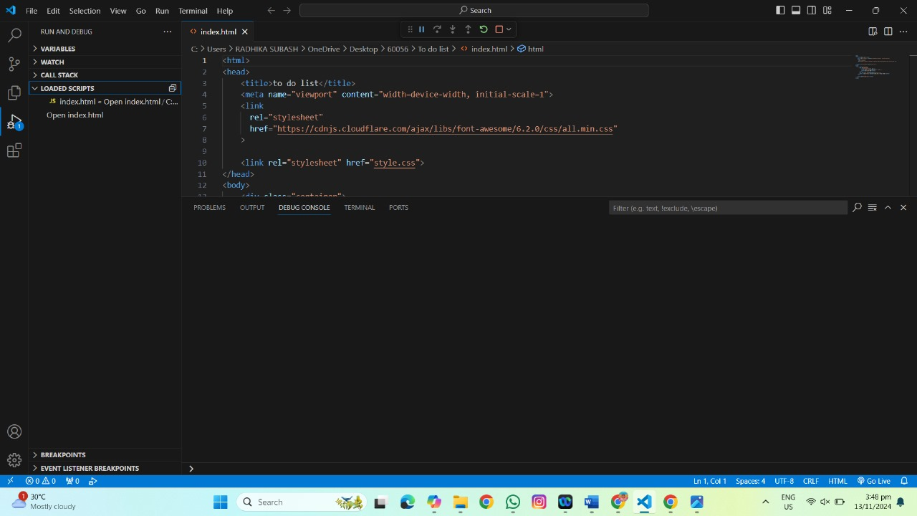

Fig 3.1.2 **HTML Code Execution**

CSS enables responsive design, allowing the layout to adapt to different screen sizes, making the application accessible on desktops, tablets, and smartphones. Additionally, CSS frameworks like Bootstrap can be incorporated to quickly implement standardized styling, making the design process faster and ensuring a professional look.

**3.2 JAVASCRIPT**

Positioned as the primary scripting language on the frontend, JavaScript is responsible for managing the communication between the user interface (built with HTML and styled by CSS) and the backend RESTful API, allowing users to interact with the system seamlessly. JavaScript’s primary function in this project is to handle AJAX (Asynchronous JavaScript and XML) requests, enabling asynchronous communication with the backend API. This means that when a user performs an action, such as adding a new item, updating inventory details, or deleting an item, JavaScript can send an HTTP request to the backend without requiring a full page reload, keeping the interface responsive and user-friendly.

4



Fig 3.2.1 **JavaScript**

This asynchronous communication is vital for providing a real-time, interactive experience. In addition to handling data fetching and display, JavaScript enables interactive elements that enhance usability. It powers actions like hover effects, button clicks, and form submissions, making the interface more responsive and intuitive.

JavaScript’s flexibility also supports error handling in API calls, allowing the application to catch errors and provide feedback to the user if something goes wrong, such as network issues or invalid requests. This is particularly useful for displaying meaningful messages, like “Item added successfully” or “Error: Could not delete item.” Additionally, JavaScript’s interaction with CSS allows for dynamic styling adjustments, like highlighting table rows when selected or changing button colors based on user actions, making the interface feel responsive and alive.

Overall, JavaScript acts as the bridge between the frontend and backend, managing the user interface's dynamic behavior, validating data, handling real-time updates, and ensuring smooth communication with the RESTful API. By integrating with HTML and CSS, JavaScript transforms a static web page into a fully interactive, responsive, and user-centric application, enhancing the efficiency and usability of the inventory management system. This extensive use of JavaScript ensures that users can intuitively and efficiently manage inventory data without technical complexity, making it a critical component in delivering a smooth and satisfying experience.

5

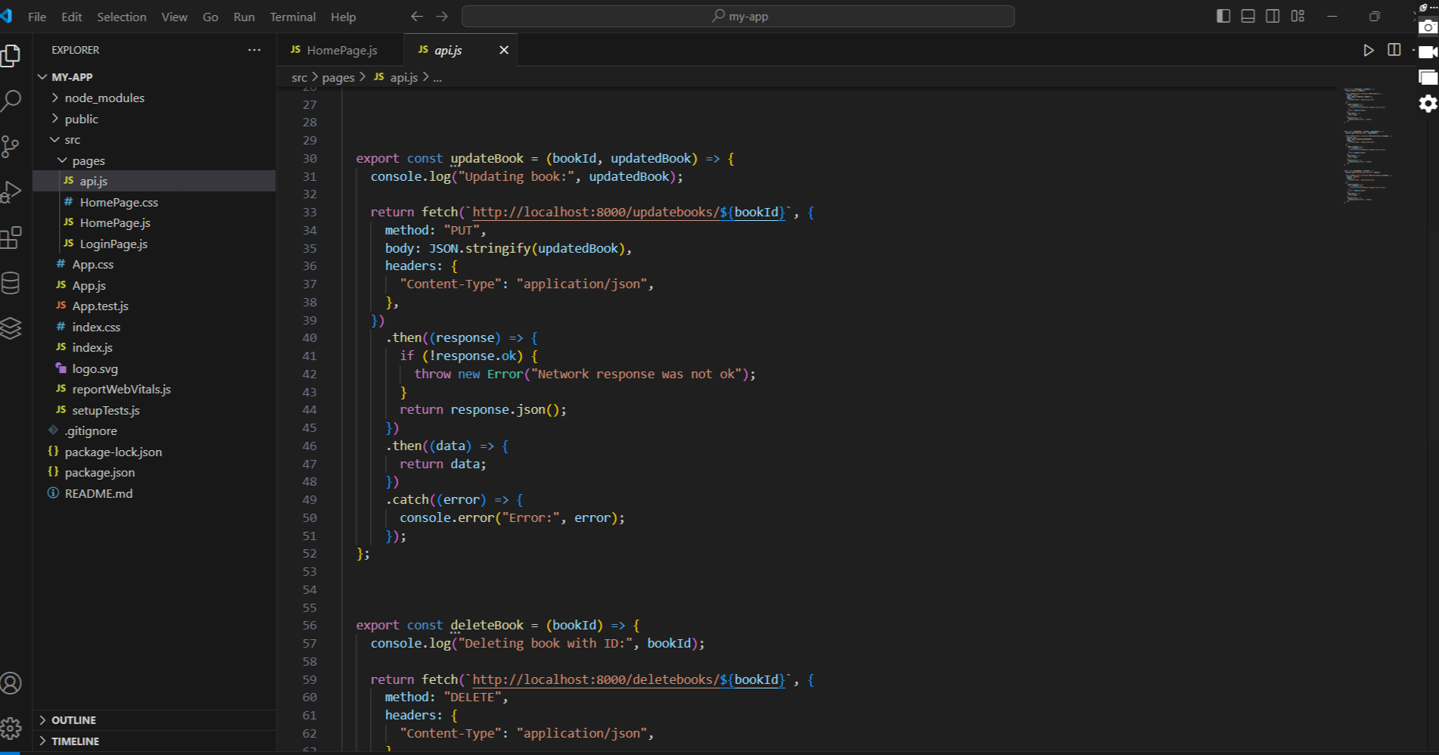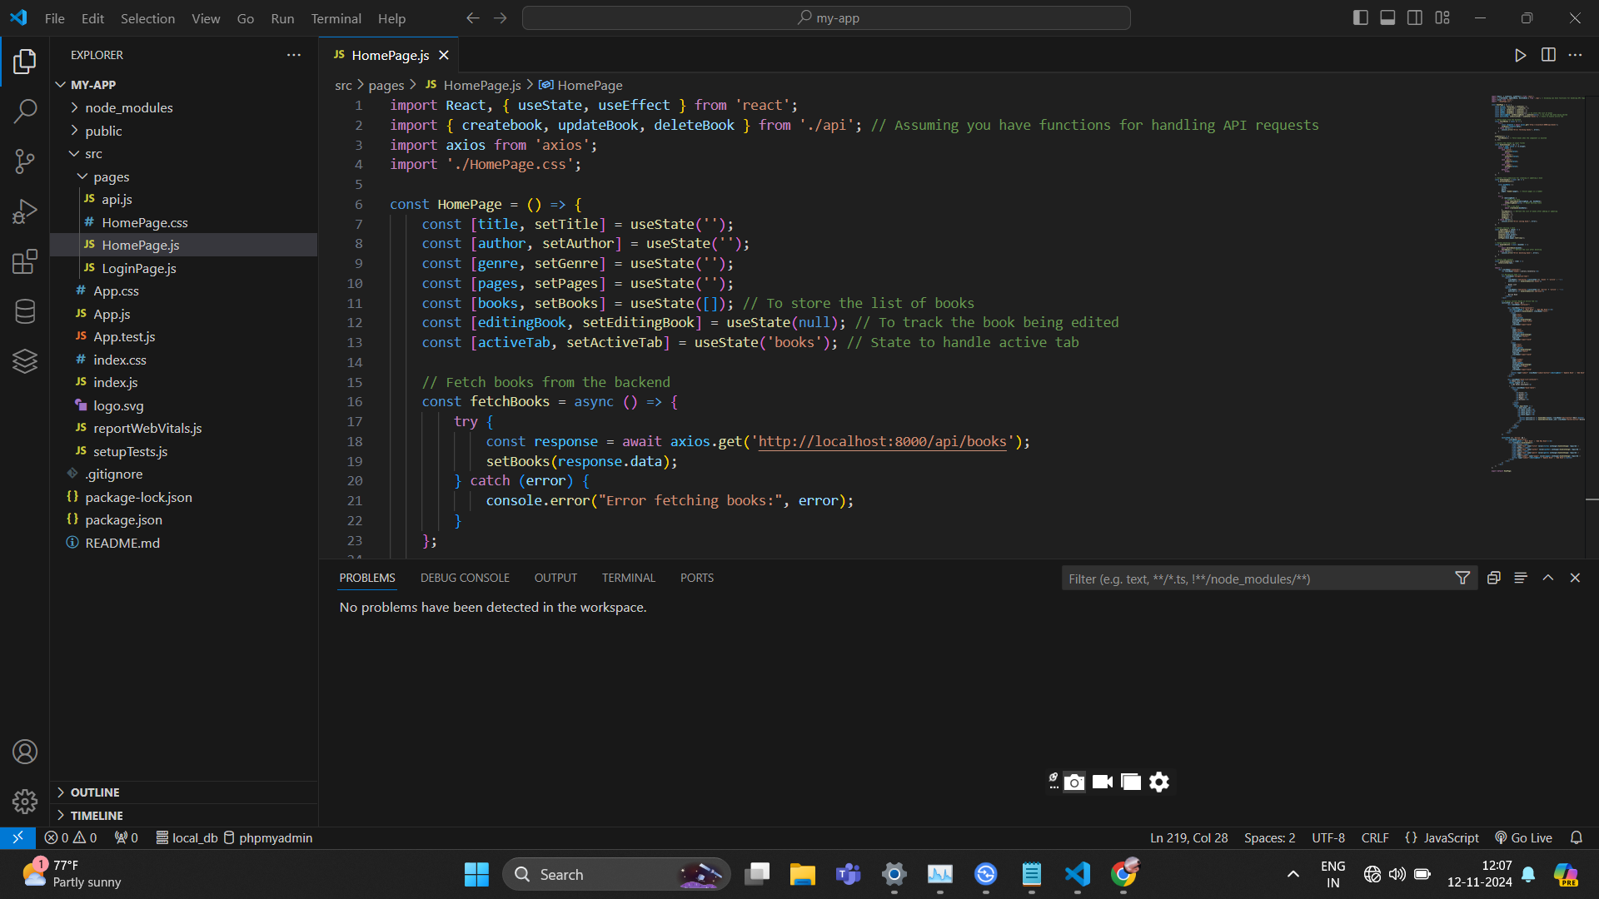

Fig 3.2.2 **JavaScript code Execution**

6

**CHAPTER-4**

**SYSTEM FLOW**

In a "Scalable To-Do Application using SaaS," the system flow would generally include the following core components and stages. This explanation will focus on a cloud-based, scalable approach that leverages SaaS (Software as a Service) principles to support multiple users with robust data storage, high availability, and scalability.

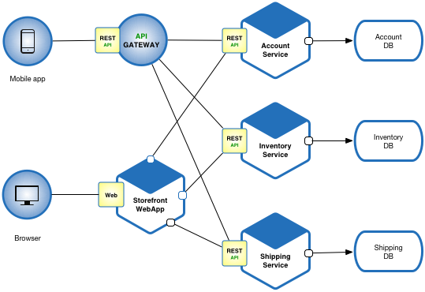

Fig 4.1.1 **System Flow**

* **User Registration and Authentication**: New users register using an email, username, or phone number and set up a password or use Single Sign-On (SSO) methods (Google, Facebook, etc.). An authentication microservice or third-party service (e.g., Firebase Auth, Auth0) handles secure login and logout. Multi-factor authentication (MFA) might be implemented for added security.

7

* **Frontend UI and User Interaction**: A web-based front end, mobile app, or desktop application serves as the user interface. It connects to the backend APIs to send and retrieve data. Users are presented with a clean interface to create, view, edit, and delete to-do tasks. Additional options may include filtering tasks by category, priority, or deadline.
* **Task Management (CRUD Operations)**: When users add a new task, they provide attributes like title, description, due date, priority, and category (e.g., personal, work). Client-side and server-side validation ensure that tasks meet predefined requirements (e.g., no empty titles).
* **Task Syncing and Real-Time Updates**: If real-time collaboration or updates are needed, a WebSocket connection or similar technology allows for instant synchronization of data. This is particularly useful when multiple devices are used or when tasks are updated frequently.
* **Scalability and Load Balancing:** A load balancer distributes incoming user requests across multiple backend servers, ensuring even traffic distribution. This helps prevent any single server from becoming overwhelmed, which is essential for maintaining a responsive application under high load.
* **Monitoring and Logging**: Services like AWS CloudWatch, New Relic, or Datadog provide real-time insights into the health of the application, allowing the team to track usage patterns and performance metrics.
* **Continuous Integration and Deployment (CI/CD):** Testing is integrated into the CI/CD pipeline, including unit tests, integration tests, and end-to-end tests. This ensures code quality and reduces the risk of bugs in production.
* **Data Analytics and Insights:** Data analytics provide insights into user behavior, popular features, and potential pain points, guiding future development and feature updates. Dashboards can display KPIs like user retention, average task completion rate, and feature usage frequency, supporting informed decision-making for SaaS improvements.

8

**CHAPTER-5**

**INTERFACE OF THE SCALABLE TO-DO APPLICATION**

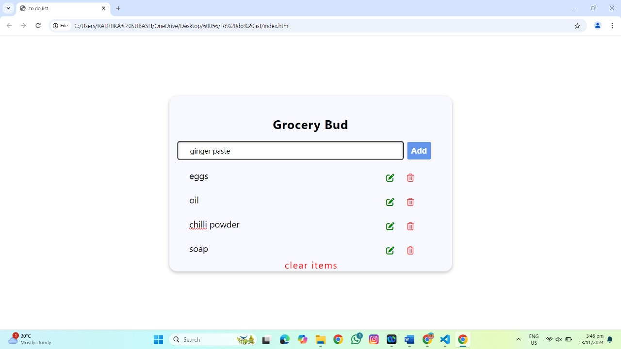

Fig 5.1.1 **Interface of the Scalable To-Do Application**

9

**CHAPTER-8**

**CONCLUSION**

The "Scalable To-Do Application using SaaS" project successfully demonstrates the power of cloud-based software in delivering a seamless, responsive, and highly customizable productivity tool for users at any scale. By leveraging SaaS principles, this application is not only robust in terms of handling increasing user loads but also dynamic in catering to individual and organizational needs. The application's foundation on microservices architecture allows for specific task functionalities—such as task management, notifications, and user authentication—to operate independently. This design enhances the modularity of the system, facilitating smooth updates, fault tolerance, and scalability. With separate microservices for user management, task notifications, and API gateways, the system can easily scale horizontally by adding more instances of each service as demand grows, ensuring continuous uptime and low latency even under high loads.

An equally vital component of this project is the backend infrastructure. By implementing load balancers and serverless functions, the backend remains robust and adaptive, managing resource allocation effectively without incurring unnecessary costs. For example, serverless functions allow background tasks, like sending notifications or processing reminders, to be handled independently of the main server operations, ensuring that users face no lag in their primary tasks. This architecture provides cost efficiency and performance optimization, as resources are dynamically allocated only when required. For high availability, load balancers distribute traffic across multiple instances of the backend services, reducing the likelihood of downtime and ensuring that the system can handle traffic spikes during peak usage.

In conclusion, the "Scalable To-Do Application using SaaS" exemplifies how modern software can be designed to support individual productivity and collaborative task management at scale. Through careful attention to security, reliability, scalability, and user experience, the application not only meets the current requirements of a dynamic, cloud-based task management tool but also positions itself for future growth.

10

**CERTIFICATES**

